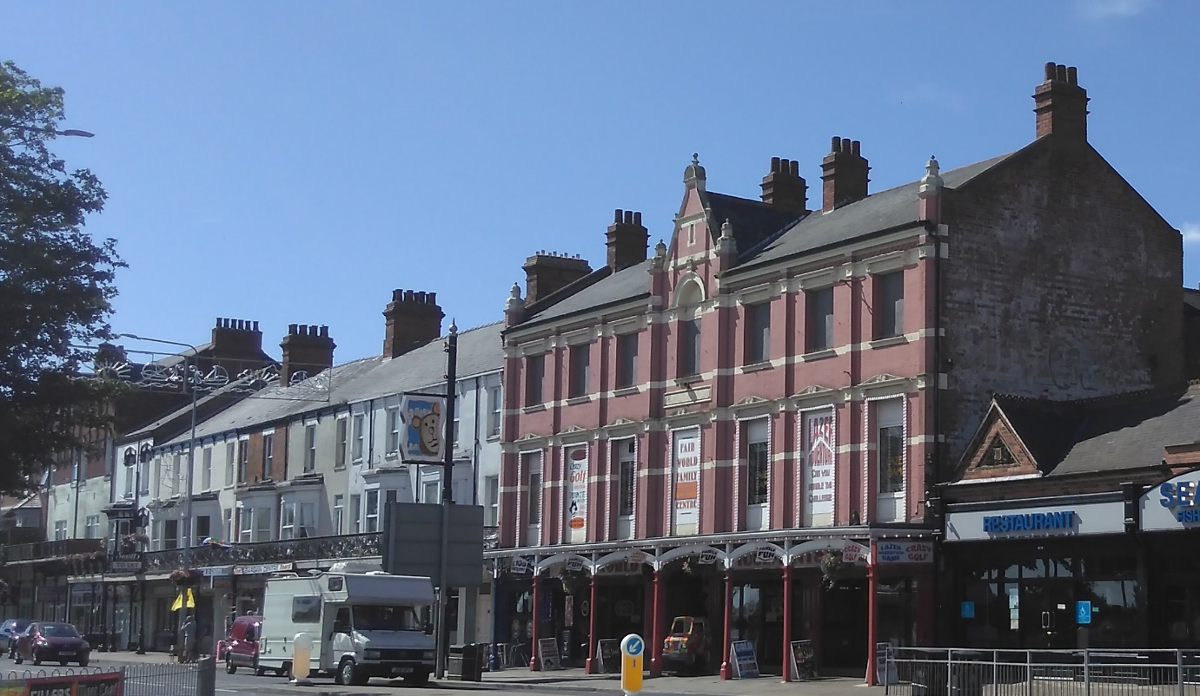

Discover Cleethorpes Heritage

Heritage Lottery Fund Townscape Heritage
Appendix 2 - Technical Guidance

Background
Character Areas
The Cleethorpes Central Seafront Conservation Area Appraisal 2016 identifies four character areas within the Conservation Area boundary. Although there are a number of exceptions, one of the defining characteristics of Cleethorpes is the overall degree of unity and integration in respect of materials, detailing, scale and built form. Within this consistent visual appearance there is variety and interest, as well as distinct character areas which sub-divide the conservation area into separate zones, each with their own individual characteristics. These characteristics are not only physical, but also influenced by activity and use. Some of the character areas are also more established than others, but they are all distinctive and this distinctiveness should be recognised and built upon in future regeneration projects.
- Sea View
- Market Place & High Street
- St. Peter’s
- Seafront

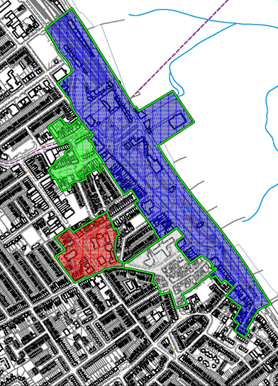
Only the Sea View and Seafront character areas are included within the Discover Cleethorpes Townscape Heritage focus area and described in this document.

Key to show the character areas with the Conservation Area

Sea View

St Peters
Market Place & High Street
Seafront

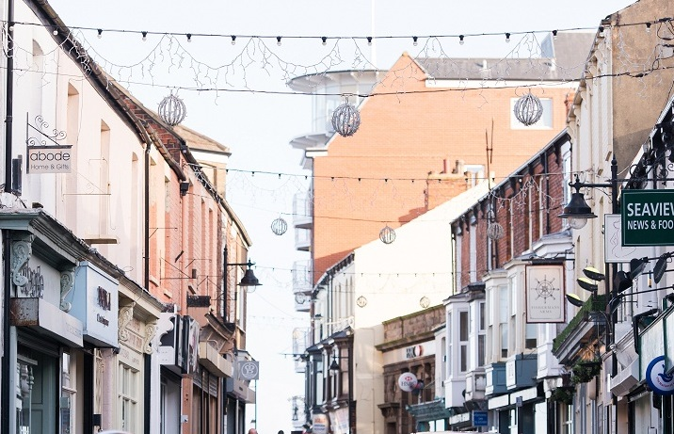

A photograph of buildings in the Seaview character area
Sea View Street Character area

Challenges

- Need to maintain active ground floor uses
- Prevent street clutter from obstructing the highway and blocking views towards the sea
- Reduce the impact of traffic and improve the pedestrian environment
- Look to reduce the use and impact of security shutters
- Encourage more events and improve public realm to facilitate this
- Need to carry out building improvements to repair and reinstate architectural features to strengthen character.
- Support the area as a key destination ‘Sea View Quarter’.

Sea View Street is a very narrow historic street with two and three storey development. Narrow plots, a continuous building line against the back edge of the pavement giving rise to a sense of enclosure and containment. Buildings are generally of red brick, often painted with pan tile roofs. There is some variation in roofline at eaves level with different storeys along the street.
A slight bend in the street with a glimpse of open sky at the end invites investigation of the sea front. Four buildings facing the junction of Sea View Street and Cambridge Street have been designed with formal corner features including the Art Deco style Queen’s Hotel 28 Sea View Street with a brick and Faience façade.
Many historic shop fronts are retained (in whole or in part), adding substantially to the architectural merit and character of this area. Deep fascias and well detailed corbel brackets are a feature of shop fronts (however, many are marred with the addition of external box shutters). Architectural merit can also be found in the form of dressed stone, brickwork and high quality architectural details.

Challenges

- The need to maintain active ground floor uses
- Consider a greater mix of uses
- Prevent street clutter from obstructing the highway and creating a visual block along the street scene
- Encourage the link between High Street and Sea View Street
- Reduce the impact of traffic
- Introduce new and improved pedestrian crossing points
- Look to reduce the use and impact of security shutters
- The need to carry out building improvements to repair and reinstate architectural features to strengthen character
- Need to create consistency between public and private realm.
A photograph of buildings in the Seafront character area

Seafront Character Area

The Seafront character area is representative of the traditional seaside town created as a result of Victorian investment in the railway. The current uses are predominantly restaurants, hot food outlets and bars with residential uses above.
Alexandra Road has predominantly three and four storey development (making the most of uninterrupted sea views) which provides a continuous architectural frontage to the pleasure gardens opposite.
A varied roofline provides much architectural interest and is derived from differing building heights with additional architectural embellishment such as Flemish and shaped gables to some buildings. A very clear horizontal emphasis and continuity is derived from the highly decorative cast iron balconies which line the street, extensive promenade and linear roadways.
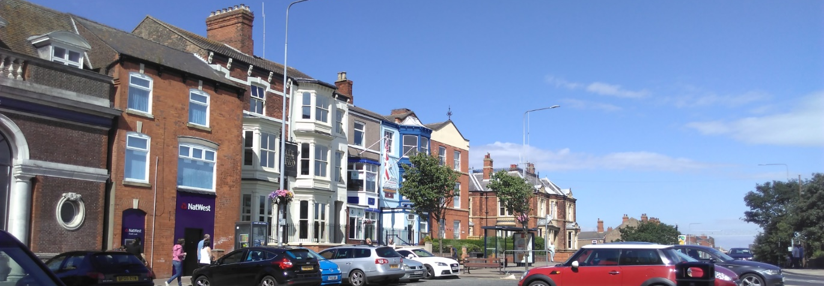
Planning Policy Context

The purpose of the document is to amplify guidance in planning policy set out within the following documents.
This section of the guide references and is based on the relevant national and local planning policies and strategies and is consistent with the following policy documents.
- Planning (Conservation Areas & Listed Buildings) Act 1990
- National Planning Policy Framework
- North East Lincolnshire Local Plan
- Town Centres Investment Plan
- Conservation Area Appraisal
- NELC Outcomes Framework and Commissioning Plan

Design Guidance
Authentic reinstatement of lost architectural features
The authentic reinstatement of lost architectural features is a key element of this grant programme. The impact of this type of work is transformational and can significantly enhance both the host building and its neighbours, as well as the conservation area. If any features are missing from a building, and other grant aided work is sought, it is expected that reinstatement of lost architectural features will be included in the proposed scheme.

This is a one-off opportunity to address vital elements that once contributed to the character of the conservation area with grant aid. It is acknowledged that many of these features cost more than most owners find economically viable to undertake and therefore, the rate of grant is high, with up to 80% being made available for this kind of work. Applications for grant aid that do not include reinstatement where this is considered essential to the appearance of a building are likely to score less highly when assessed and may result in the application being declined.

Typical features for reinstatement include:

- shop fronts (including missing elements of original shop fronts)
- windows/doors
- balconies
- architectural decorations/features (e.g., missing stone finials, and other decorative details).
- Other missing historic architectural features will be considered on merit by the TH Officer as a possibility for grant aid.
Authenticity of design is crucial, and a requirement of Heritage Lottery Funding. Documentary evidence is needed to demonstrate and inform the design process. The following may assist:
- The Townscape Heritage Officer may also be able to provide evidence;
- Neighbouring buildings which form part of a terrace may still have details that your building does not;
- Original features beneath modern features (this is particularly the case with shop fronts).
- Old photographs. The Historic Environment Record has old photographs of the TH area. The search is free. https://www.nelincs.gov.uk/planning-and-development/heritage-and-conservation/#1455897915842-cead4778-3866
- Old Plans and Photos. These may be found at:
NELincs Archive - https://www.nelincs.gov.uk/libraries-and-archives/
Historic England Archive - https://historicengland.org.uk/images-books/archive/
Bygones (Grimsby Telegraph Archive) for old photos.

If all the above sources have not resulted in documentary evidence, then by agreement with the TH Officer, it may be possible to produce an authentic period design based on the age and style of the building.
Shop fronts
Where an existing historic shop front exists, repairs and reinstatement of missing details will be expected rather than replacement. Where a modern inappropriate shopfront exists, a new authentic period shopfront will be required as part of the grant scheme. Shop fronts are to be made of traditional materials. Metal (unless proven historically to have been an original detail, for example, an Art Deco shop front) and PVCu shopfronts will not be acceptable for grant aid and are not acceptable materials for a listed building or in a conservation area.

All shopfronts must be manufactured using traditional joinery techniques. Routered details are usually unacceptable. For example, a panelled door will consist of a flush, raised or raised and fielded panel set within a four-piece fully jointed frame (as compared to a routered incision to form a panel in a material such as MDF which can never replicate the depth and quality of traditional joinery). Mullions, transoms, cills, stall risers, pilasters, console brackets, corbel brackets, entablatures, and all decorative mouldings are key elements of design.

Many historic shop fronts are designed without door recesses. Side returns on recessed doors are common in the area, and on large shop fronts, a recessed door is set between two matching shop fronts to either side. Flat shopfronts are much more unusual, and even when there is no distinct door recess, the mullion and door frame are carefully thought out features with the door set slightly in recess.

Design in Context
Shop fronts form part of a whole building frontage and it is important to treat them in context and not in isolation. Consideration should be given to the style and period of the building. The opportunities and constraints of the ‘host’ building and adjoining buildings should be identified before starting a new shop front design. This will help to inform the approach for the design.
Changes to shop fronts should be considered in relation to the context of the street and how it fits into the existing pattern. The width of the street and height of the buildings generate an appropriate scale for its shop fronts. The style and importance of the street can also help inform the arrangement of the different elements of the design. New or altered shop fronts should be designed to fit into this existing pattern and not try to compete visually with them, as this can cause harm to the character and appearance of the street scene.

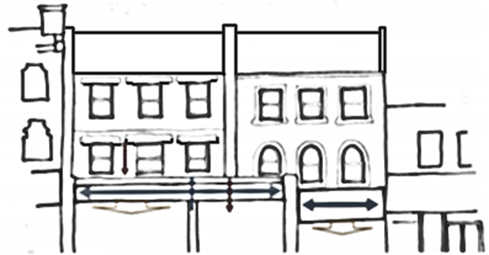
Right: Before - The link between the lower and upper floors has been lost by large expanses of glass and loss of visual support, especially beneath the party wall.

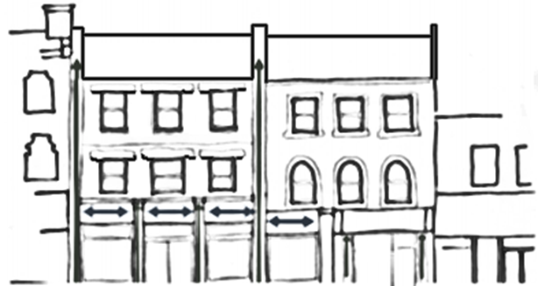

After: Through the use of pilasters or mullions a visual support is provided linking the ground floor to the upper floors and redefining the separation between the two buildings. This also reduces the size of the facia and glazing.

Traditional shopfront plan forms
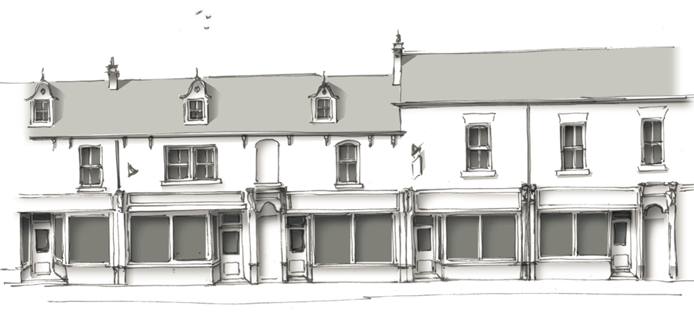
Source of image Buttress
Traditional shopfronts often have a recessed entrance. It is important to look for evidence of any previous features, such as tiled, mosaic or terrazzo entrances or a step into the shop. Old photographs may indicate a recessed entrance existed. A recessed shopfront increased display space. Where these features exist, they are to be retained and repaired. New shop fronts will need to consider this level of detail.

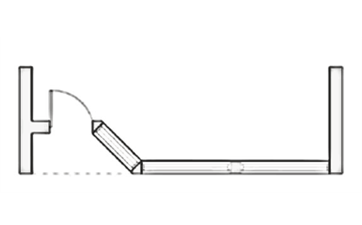
Off centre with canted recess
The recessed doorway whist adding depth and visual interest to the elevation provides a lobby area with an opportunity to incorporate advertisements against the adjacent party wall. The recess can be to the left or right-hand side but should have some symmetry with the adjoining properties.
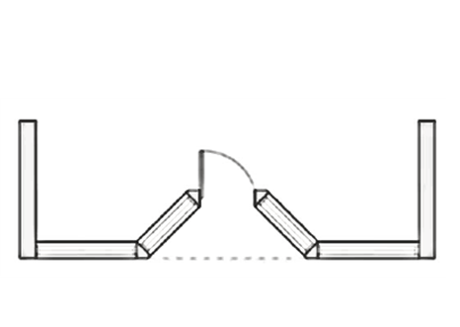
Central, with paired canted recess
A central recessed entrance flanked by canted windows creates two distinct display areas. The layout allows for a symmetrical elevation, often used when a shop front extends over two units. The angle of the recess can also be altered to allow for a wider entrance door or even double doors if necessary.
Other details that are important to consider and include in your application for the repair of existing shop fronts or for newly designed shop fronts (subject to documentary evidence) are:
- Tiled stall risers
- Mosaic tiled floors in door recesses / stall risers / pilaster panels
- Stained glass / engraved glass panels
- Decorative mullions
- Carved spandrels
- Mirrored panels (on pilasters) sometimes with gilded lettering
- Original ironmongery where existing should be retained
- New shopfronts should utilise good quality appropriate new ironmongery in a style appropriate to the design period.
- Faience details (pilasters, console brackets and external walls)
- Canopies and associated ironmongery should be retained
- Corbel brackets
- Decorative mouldings
- Raised and fielded panels
- Timber carved details
- Ground floor passage doors and doors to upper floors need careful consideration and are usually carefully designed as part of any new shop front.
- Fanlights and top lights above doors
- Traditional signage

Scaling the approximate size and details for a new shopfront can be undertaken using old photographs to inform new shopfront design to ensure correct historic proportions are utilised.
Historic details should be replicated from appropriate examples found locally where a photograph is not sufficiently detailed.

Quality of detailed plans is crucial. When planning permission or listed building consent is considered, it will be necessary for the proposed design to show clearly the intended design and plan of the shopfront. A condition will be added to decision notices and any offer of grant for a 1:20 scale clearly annotated construction drawing of any new shop front for approval in writing by the TH Officer and the LPA prior to manufacture. Details will also need to be shown at a scale of 1:1 for mullions, transoms, glazing bars and mouldings. Horizontal and vertical sections through are also required. Samples may also be required.
Any existing external shutters will need to be removed for the purposes of grant aid. Alternatives are actively supported and may be eligible for grant aid. The following alternatives should be considered:

- Toughened glass (which is in any case a requirement of building regulations for any new shop front with glass below 800mm from any floor level) is often the preferred option as it makes very little difference to the appearance of a shop front. Planning permission will only be required if its installation results in a change of appearance, for example, the removal of stained glass. If the building is listed, Listed Building Consent will be required.
- Internal security systems such as rolling grilles or perforated roller shutters can be installed without the need for planning permission. If the building is listed these methods may require Listed Building Consent. This option allows goods to continue to be on display during close hours maximising potential sales.
- Bomb proof film (to existing historic glass).
- Demountable external shutters may be considered. These have been used historically, along with reticulated panels for door protection.
- Decorative iron gates to recessed entrances have also been used historically to protect these areas of a shop front and may be an acceptable way to block recessed entrances used for shelter or other unsociable uses during closed hours.

Where alarm systems are in use it is advised to locate the alarm box in a position which causes least distraction such as a side or rear elevation. If this is not possible then the box should be hidden within the facia or soffit. In some cases, it may be appropriate to paint them to match the surface which they are fitted to. Alarms are not eligible for grant aid.
Shopfront and traditional signage
Traditional signage is a key element of a period shopfront. Appropriate traditional signage is eligible for grant aid. Individual V-section letters were very popular forms of fascia signage in the Victorian period. These were often gilded and covered with glass, or a similar effect was obtained by impressing letter of V-section into copper sheets with steel dyes and covering them with glass, known as ‘Brilliant’ signs. Stock letters were also purchased in wood, metal or porcelain for use on fascia’s, the most common being half round wooden letters, usually gilded, rather than hand—painted. However, most fascias were hand-painted, often with shadow letters. Gilded lettering may also have been applied directly to the windows of a shopfront.

Traditional signage is encouraged and supported by grant aid. Signwriting is directly applied to the fascia, or traditional hanging signs, and sometimes adverts directly on the wall of a historic building. Lettering needs to be in an appropriate contrasting colour to the shopfront and of a size that does not overwhelm the building. Traditional fonts are required. Typical Victorian and Edwardian fonts are:
- De Vinne
- Soria
- Ronaldson (1884)
- Clementhorpe

During the 20th century, Art Nouveau lettering became popular. Lettering became more streamlined in the Art Deco period. Lettering types include:
- Goudy Sans FS (l929)
- Le Havre

It is recommended that projecting signs have a minimum vertical clearance of 2650mm to the underside of the sign from the pavement. The minimum horizontal clearance between the sign and carriageway should be 900mm, hanging or projecting signs are traditional forms of advertisement. Consideration is needed in terms of location to avoid creating visual clutter, particularly if signs are located at different levels. Projecting signs should also not be too large and should not compete/obscure neighbouring projecting signs in respect of scale or location. It would be unusual for a projecting sign to exceed 900mm in any one dimension. Signs located above first floor level of the shop window are usually not granted consent. Reference will be made to any documentary evidence to inform new signage.

Colours
Colour is important on a shop front as it sets the tone of the area and can attract customers and can act as an advertisement in its own right. Colour schemes for shop fronts in conservation areas or in historic towns should complement the existing townscape where possible.

- Rich colours such as the darker shades of blue, green and red are more traditional colours and are likely to be preferred colour schemes, particularly when upper floor joinery has a contrasting pale colour as part of a bi-coloured scheme.
- Brighter colours can be distracting in an historic environment and can detract from the character of the building and the street any may be unacceptable.
- Colour can be used to pick out architectural features and give a shop front a sense of depth and character using bi-coloured schemes.
- It is also good practice to use the same colour scheme on any additions to the shop front such as hanging signs or blinds, giving a sense of uniformity.
- It is important that historic streets maintain diversity. They should not become a place of cloned shop fronts each with the same design and/or colour scheme. Each individual shop should be unique through architectural features, design and colour, but give consideration to other shops.
- Standard corporate colours and signage may be unacceptable.

Traditional paint colours acceptable in the Townscape Heritage area are:
  - Black Red - RAL 3007
  - Chrome Green – RAL 6020
  - Olive Green - RAL 6003
  - Purple Red - RAL 3004
  - Olive Green - RAL 7002
  - Rouge Tomato / Vieux Rose - RAL 3031/3014
  - Blue Turquoise - RAL 5018
  - Oyster White - RAL 1013
  - Grey White - RAL 9002
  - Green Blue - RAL 5001
  - Black Grey- RAL 7021
  - Lemon Yellow - RAL 1012
  - Signal White - RAL 9003

There are also other heritage colours available from branded traditional paint ranges which are also likely to be acceptable.

Gloss paint is a traditional finish for Victorian and Edwardian buildings. Eggshell paint is a traditional finish for early to mid19th century buildings.

Decoration is eligible for grant aid if other works or repair or reinstatement are also the subject of grant aid. Decoration of existing buildings not in receipt of grant aid for any other works are not eligible for grant aid as this work is classed as routine maintenance.

Balconies
Balconies are highly significant features on Alexandra Road. The retention, repair and reinstatement of missing features is encouraged through the Townscape Heritage Scheme. Group applications for grant aid are particularly welcomed, especially where the same design of balcony is used on a terrace. Balconies mostly consist of cast iron, with many now more than a hundred years old. Many also channel rainwater as part of their original design and are prone to rust. See section on cast iron for repair methods. The design of the original balcony, and any replacement components must match the original in all respects. Where a balcony is missing or has missing elements authentic reinstatement is required. Signage and other extraneous fixtures on balconies should be removed.

Windows

Repair of historic / original

Where these exist retention and repair is a requirement of the scheme. Original and historic windows are often made of superior timber to more modern windows and if they have been regularly maintained, are usually capable of repair. Conservation of Timber Sash and Case Windows produced by Historic Scotland is widely accepted conservation-based guidance on the assessment and repair of historic windows.
https://www.historicenvironment.scot/archives-and-research/publications/publication/?publicationid=ae41ad09-7905-42d3-a8dc-a5ad00a3cf26

This guidance states:
‘In almost all cases, repair of the components on a like-for-like basis is preferable to replacement of a whole unit, as this will best maintain the character and historic fabric of the window’. (Para 4.3)

‘Where there is no alternative to the replacement of historic windows or elements of their joinery or glazing, the new elements should match the original. This should include replication of the proportion, opening method, astragal dimensions and profiles, and fixing of glass’. (Para 4.4)

‘In exceptional circumstances, such as conversions, there may be grounds for the removal of existing windows and their replacement with new, more thermally efficient ones. Normally this will only be considered where the existing windows are inappropriate, or incapable of repair and the new windows can match the design of the historic ones’.
Splicing in new timber and replacing defective elements is acceptable. Resin repairs or combined timber and resin repairs may also prolong the life of historic windows. Old glass should be retained or reused wherever possible. Both timber splice and resin repairs may be offered grant aid.
Thermal upgrading of existing windows
Thermal upgrading of existing windows can be achieved using three methods. These are:

- Draught stripping – adding patent draught strips to existing windows can reduce draught and rattle associated with historic windows. These are fitted where they are not visible externally on meeting rails and staff beads and can substantially reduce draught and rattle, often associated with traditional sash windows;
- Adding slim line double glazed units to existing windows. The successful incorporation of double glazed units depends on the thickness of the glazing bar (if there is one), the size of the sash or casement frames, and whether the windows have weights and pulleys to open them (vertical sliding sash windows). Windows with a glazing bar measurement of less than 23mm (across the widest part) are unlikely to be able to incorporate successfully double-glazed units without the units being visible. Generally, most mid to late Georgian bars can be less than this measurement, and glazing bars of the Regency (circa 1810 – 1830) are often as slim as 18 – 19mm. Victorian windows may have a thicker glazing bar if the window panes are very large.

  - Wider glazing bars may be able to accommodate a slim line double glazed unit consisting of a 12mm double glazed unit consisting of a 4 X 4 X 4 (glass – spacer – glass) arrangement.
  - To avoid the unsightly black spacer bar being seen, a white, off-white or silver spacer bar can reduce the visual impact of the double-glazed unit where sashes are to be painted a light colour. Skilful joinery can incorporate double glazed units into a new design where a ‘putty line’ glazing bar can still utilise individual panes. Some windows can still have a proper putty detailing to retain glass. The latter is preferred as an authentic detail.
  - The smallest double-glazed units are produced by one manufacturer and these can be as slim as 9mm and are set into windows with putty in the traditional way and can be used with a 17mm glazing bar.
  - Vertical sliding sash windows would need to have weights replaced to work with the additional weight of double glazing. Many Victorian windows have cast iron weights. Lead weights can be utilised instead and are often the same size as cast iron weights, meaning there is no change to the box.

- Secondary glazing – which can be permanent or temporary (removed seasonally). Provided the design does not compromise the design of the existing windows, this is acceptable as an alternative. Secondary glazing may be eligible for grant aid where original single glazed windows are retained and repaired, or where new windows must be single glazed for authenticity.

Design of new, replacement and reinstated windows

New windows need to be authentic in detail. All new windows should include patent draught strip which can be carefully concealed (unless secondary glazing is to be utilised). Double glazed units may be incorporated (as per technical guidance note b) ii of this document). Timber should be close grained hardwood capable of taking a microporous stain finish. This will assist with longevity in a coastal climate.

It may be the case that the changes that would need to be made to the design of a new window have such a cumulative impact that the original design is lost. In such cases, single glazing will be required. Secondary glazing can instead be utilised.

PVCu and aluminium windows (unless an original or historic metal windows is being replaced), and applied and interstitial glazing bars are unacceptable details for grant aided work.

Window colours will need to be complementary to any ground floor shop. Brilliant white was not used until the 1950’s when titanium was added to paint. Until then off-whites were utilised. Cills should normally be a contrasting colour to the window frame, and bi-coloured paint schemes were very popular in the late19th and early 20th century. See also paint colour schemes for more information.

Cast Iron

Cast iron repairs and replacement on a like for like basis are eligible for grant aid. Cast iron can be difficult, though not impossible, to repair. It is therefore advisable to seek specialist advice.

Original cast iron detailing on rainwater goods and balconies should be retained where this is in good order. Where elements are failing grant aided works will be considered on the following hierarchy:
- Straight sections such cast downpipes or hoppers that are standard in section and readily available in the exact same pattern as new components should be replaced on an exactly like for like basis (usually applies to rainwater goods).
- Structural and decorative cast iron (such as columns holding up balconies and balusters) in good repair to be retained in situ and refinished.
- Structural cast iron in poor repair or damaged very badly should be assessed for in situ repair using cold stitching. This is a simple but effective method of repairing cracks in cast metals without the need for welding. The vast majority of repairs can be done in situ, with little or no dismantling saving time and money.
If this is not a suitable method then depending on the availability of new matching components, an exact replacement may be considered.
Where a component is unique, and a new mould would be required to cast a new piece, this would be considered if a group of buildings may need the same component. Alternatively, following suitable assessment, the element may need to be temporarily removed for specialist cast iron welding by a suitably experienced craftsperson.
There are a several iron foundries producing traditional cast iron rainwater and other decorative goods and they usually hold a wide range of traditional patterns in stock or can cast using existing moulds to order. Cast aluminium, fibreglass, plastic and steel are not appropriate substitutes. Stainless steel fixings are generally recommended.
Where the existing paintwork on cast iron is in poor condition, it may be necessary to remove it entirely before repainting. However, removing paint surfaces in entirety can result in the loss of a protective layer resulting from manufacture. If ironwork is listed or of special historical interest, the removal of original paint layers will need careful consideration and may merit further paint analysis to determine the original colour scheme that was used. Paint removal is key too for existing cast iron features and is often required for effective repairs to be undertaken. The method of paint removal requires careful consideration and is a highly specialised area of work. Flame guns are not to be used as heat can impact on the structural integrity of the iron. Specialist advice should be sought prior to any paint removal.
Re-painting cast iron. If a complete repainting is required, current best practice recommends two coats of a zinc-based primer, and one coat of micaceous iron oxide (MIO), followed by two coats of gloss paint. Slightly different colours can be used for each undercoat to help distinguish one coat from another.
Wrought iron

Wrought iron was used widely in the 18th century and for gates, railings and fanlights above external doors and decorative windows. It is very rare to find original wrought iron. Where this survives it will be a requirement to retain and repair this if grant aid is sought. It is important that an appropriately qualified and experienced person carries out any necessary repairs to wrought ironwork and that traditional detailing and techniques are used. Wrought iron is currently only available as recycled material and can be comparatively expensive in relation to mild steel. However, while mild steel is the most commonly used alternative material to repair or replace wrought iron, this is generally not recommended. Wrought iron is widely considered to be more durable than mild steel and is therefore likely to reduce the need for future expenditure on repair-work. Many components from the mid-20th century are mild steel, mistaken for wrought iron, which when in poor repair shows a very distinct pattern as it rusts and delaminates which distinguishes this material from cast iron and mild steel.

Lead

Lead was used historically for rainwater goods during the 17th and 18th centuries. Any surviving lead hoppers or downpipes in the Townscape Heritage area would be considered rare survivals and repair would be required, wherever possible, and should repair not be possible, then an exactly new matching component would be made from lead (cast).

Lead is more commonly found in the Townscape Heritage area as a traditional flashing on roofs, dormer windows and on the top of traditional shopfronts. Where lead exists, it is expected that lead will be repaired or replaced if this is beyond practical repair. Where lead has been removed and replaced with mineral felt or other inappropriate materials, it is expected that lead will be used instead for grant aided repairs.

All lead works undertaken for grant aid must be undertaken in accordance with the Lead Sheet Association (LSA) manual to British Standard BS EN 12588. Lead works are eligible for grant aid.
Good quality lead substitutes may be considered in vulnerable locations. Terne-coated steel is an acceptable alternative material, but glass reinforced plastic (GRP) is not.
Stone

Stone dressings, cills and other decorative finials are found in the TH area. Where these can be repaired, a good quality stone repair may be undertaken by a suitably qualified stonemason in accordance with Stone Federation Guidance. All stone will be indigenous stone to match the original. Non-indigenous stone and artificial stone will not be acceptable materials for grant aid.

Architectural terracotta

Architectural terracotta details are found on many buildings in the TH area. There was a large brick and terracotta manufactory in Cleethorpes and it is likely that many of these details were made locally. Architectural terracotta, depending on when it was made was either hand pressed into moulds, or made from clay slip poured around a mould. Components are fired at a very high temperature. This material is notoriously hard to repair, but some polymeric consolidants can be used successfully depending on the type of damage. Components can contain rusting iron dowels and cramps and often results in the failure of the whole unit. Coloured mortar and glass reinforced plastic repairs are not acceptable methods of repair. Replacement of components is possible as architectural terracotta is still made, although not locally. Stainless steel fixings are required to avoid further internal rusting for both repairs and installation of new components.

Repair or replacement or of architectural terracotta details are eligible for grant aid.

Faience

Faience is a glazed clay material used to make external wall tiles and other decorative details, such as pilasters on turn of the 20th century buildings. Made in much the same way as architectural terracotta, the surface has a glaze before it is fired. A range of colours were available historically and some faience has a surface that imitates stone. Repair is possible, and replacements components are available.

Repair of replacement of faience components is eligible for grant aid.

Masonry repairs / cleaning
Appropriate brickwork repointing methods and correct materials are required for any works of repair where these are grant aided. There are two types of brick generally found in the Townscape Heritage area. These are:
  - Hand-made bricks of the early to mid-19th century, which sometimes show kiln firing marks (kiss marks) and are red /brown in character, slightly uneven in tone, and rarely ruler straight. These bricks were formed by hand with clay being thrown into a mould;
  - Machine made bricks of the mid-19th to the early 20th century, where mechanisation resulted in a much smoother appearance and even sizes and are larger and more regular in size than hand-made bricks.
Brickwork masonry can decay through:
- Age-related decay, particularly in a harsh sea front climate.
- Interventions such as replacing lime mortar with cement-based mortar and / or injected damp proof courses (DPC) which retain water in brickwork above the level of the DPC leading to brick erosion over time through freeze / thaw action within the brick.
Where original mortar has degraded, re-pointing is required using cement free lime-based mortar in an appropriate colour, finish and texture to match exactly the original mortar on pre19th century buildings. Mortar analysis on post mid-19th century buildings may reveal hydraulic lime has been used. Hydraulic (not hydrated) lime is widely available and appropriate for use where this has been used originally and for high level works to chimney stacks where these are exposed. Any specific original detailing should also be followed and could include:
- Penny rolled mortar joints, common on late 18th to mid-19th century brickwork,
- Tuck pointing (a fine line of white lime mortar incised into mortar that matches the brick),
On no account must any repointing be finished with struck or ribbon pointing, or mortar be smeared over the face of brickwork. Raking out of existing pointing should always be undertaken using hand tools only, raking out to twice the depth of the joint where mortar is loose. If a mechanical cutter is considered for removing mortar because it is too hard to remove by hand, then repointing is not actually required. Repointing is restricted to areas that require repointing and repointing for cosmetic purposes is unacceptable.
Damaged brickwork will need repair through the turning or replacement of brick components. Some bricks, particularly those after the mid-19th century were made with one face and turning the brick may not be appropriate.
Where new bricks are needed, these must match in size, colour and texture and be laid in matching bond. For small amounts it may be possible to source reclaimed bricks provided the provenance of the bricks is clear. New bricks are likely to be best for large areas of damage.
Removing bricks shall be undertaken by drilling individually around the brick, avoiding any damage to the brick, or with an Arbortech tool used only by a suitably qualified and experienced operative to ensure no brick damage occurs to surrounding bricks. On no account shall a mechanical disc cutter be used to remove mortar or clean joints unless this has first been agreed with the Townscape Heritage Officer. In rare circumstances, the use of a small, fine cutting disc may be used to make an incision in the centre line of very hard cement mortar, which then allows a hand tool to easily remove the cement mortar without damage, but the method must be agreed with the Townscape Heritage Officer with a sample undertaken under their supervision.
Appropriate methods for cleaning / removing paint from masonry include Jos, Doff or Torc are patented safe methods of paint removal for brick, stone and other historic materials using water and or steam with a small amount of special abrasive powder. Chemical or poultice stripping is another acceptable method of paint removal. Abrasive blasting methods usually result in damage to the protective fire-skin of a brick and are not covered by grant aid. Listed building consent may also be required for removal of paint from a listed building. Any method of paint removal requires the approval of the Townscape Heritage Officer prior to removal. A sample area is also likely to be required.
Sample panels will be required for repointing and brick replacement. Prior to a sample being undertaken, mortar ‘biscuits’ will be required for inspection to assist in choosing the best mortar for repairs.
Render, stucco and pebbledash have been used historically. Where historic render survives, this will be lime based render. Where modern render has been applied, it may be that the brick was meant to the original finish. However, unless the render is in a very poor state and can be shown to be capable of being removed without incurring further brick damage, this is best left in situ and repaired with a softer lime-based render. Where render can be removed without damage, this would be encouraged to reveal the original finish, but may result in brickwork repairs being necessary to complete the work.

Roofing

The predominant traditional roof covering is Welsh slate in the TH area. Clay pan tiles are also used but contained mostly to the Sea View Street area which has earlier origins than Alexandra Road. Both can be successfully removed and re-laid to meet current building regulations, saving on cost for new materials and reusing historic fabric wherever possible and are eligible for grant aid. Slate has a recovery rate of about 70-80%. Pantiles may be capable of re-use but the recovery rate is often only sufficient to recover one roof slope as pantiles do not have the same longevity as Welsh slate. Any shortfall should be made up of new matching materials to secure quality. Original roof coverings should used on the most prominent elevation of a building with new materials being used on rear or less prominent elevations.

Many traditional roof coverings have been replaced with concrete tiles. These will only be replaced with grant aid where it can be demonstrated that the roof is in poor repair. Grant aid will then be considered for a new roof covering of either Welsh slate or hand-made clay pantile, depending on the likely material when first constructed.

Where new slates are needed, Welsh slate is to be utilised. Where new pantiles are needed, new natural red clay hand-made pantiles are required.

Repair to historic roof timbers may also be necessary. New ‘sister’ timbers can augment the existing roof structure to allow this to be retained in situ, and traditional splice repairs strengthened with steel plates and bolts may also be acceptable. Your TH Officer will advise.
Insulation for roofs is required for building regulation if a roof covering is removed. Historic buildings need specific types of insulation to ensure that historic timbers do not sweat, which will produce moisture and eventually can rot timbers. Any insulation must be fitted properly to avoid any thermal bridging. Historic England produce a range of guidance notes for thermal upgrading in different roof types. All insulation will need to conform to this guidance.
Loft insulation is not eligible for Townscape Heritage grant aid.
The following should be observed when replacing roof coverings:

- Original slates and pantiles must be removed carefully, checked, graded and set aside for re-use. Chipped slates and tiles are not to be reused.
- New felt must be breathable and all new battens must be tanellised.
- Slates shall be twice hung using copper or stainless-steel nails (for longevity).
- Slates shall be re-holed where existing holes are damaged or broken.
- Where slates are laid in diminishing courses or diminishing in size, this detail shall be replicated faithfully.
- Under no circumstances can slates be re-installed with a ‘patchwork’ appearance (usually resulting from using additional new or reclaimed slates and mixing batches with the original).
- All newly covered slopes will have a neat appearance in both how the slates are laid and particularly in the evenness of colour
- Pantiles shall be drilled and fixed with copper nails on every third row.
- Eaves, ridge and verge details will replicate the original detailing on existing traditional roof coverings including traditional lead step and cover flashings on slate.
- Pantile roofs with a raised parapet gable should avoid dressing over pantiles and instead, utilise a secret gutter detail (found in the Lead Sheet Association Manual)
- Clips are not to be utilised on verges which should be flush where exposed, or with an under-cloak of no more than 30mm extended beyond the plane of the wall.
- Ridge tiles are important features and usually consist of a half round natural red clay ridge tile on pantiles. Slates are usually topped with a Westmorland Blue Ridge tile, or a more decorative contrasting terracotta ridge tile. Original ridge tiles are to be set aside for re-use where fit for purpose and new (or reclaimed?) ridge tiles to exactly match the original are required. All ridge tiles are to be set neatly with invisible flaunching using cement free hydraulic lime mortar (NHL 3 of 5, depending on circumstance).

Rainwater goods
Rainwater goods refers to the gutter, hoppers and downpipes on a property. Cast iron gutters in Cleethorpes are usually half round suspended with spike rise and fall brackets with round downpipes. However, on Alexandra Road the properties tend to have traditionally hoppers are made of cast iron or lead. Designs are varied, and reinstatement should follow historic evidence.
Cast iron rainwater goods should be repaired or replaced on an exactly like for like basis. See appropriate sections in this document for repair methods. Retention or renewal of plastic rainwater goods are not eligible for grant aid.
Some properties have timber gutters held up on decorative brackets or corbels. These are usually lead lined. Repair on a like for like basis and the reinstatement of any missing details will be eligible for grant aid. Hardwood should be used for longevity and lead detailing is to be in accordance with Lead Sheet Association codes and manuals for lead (see section on lead).
Some timber gutters are too small to be fit for purpose as lead cannot be laid to correct falls due to the number of joints needed. In some cases an alternative approach may be considered, e.g., cast ogee gutter on top of timber detailing to give a similar appearance.
Structural Repairs

Structural repairs may be required in some buildings. Advice should be sought from a conservation accredited structural engineer on the extent and type of repair. Generally accepted methods include:

  - Helical streel ties for structural cracking for brick masonry;
  - Replacement of rotted timber window lintels with new hardwood timber lintels
  - Augmenting existing structural timbers with new timbers alongside (‘sister’ timber)
  - The introduction of steel flitch plates to internal beams
  - Steel plates, ties and shoes to existing historic beams
  - Localised reconstruction (usually a last resort).
Demolition and rebuilding of large areas is only acceptable as a last resort, and only when supported by a report from a conservation accredited structural engineer demonstrating there are no alternatives. The cost of demolition compared to conservative repair can be more expensive and usually results in a very visible intervention.
Some historic buildings have sometimes undergone structural changes when modern shopfronts have been installed. Every effort will need to be made to ensure that any proposed new shopfront is capable of being installed as per the approved plans using the existing structural support.

Specifications for Repair

All applications for repair are required to provide a detailed, itemised specification and methodology for repairs. This should be undertaken prior to costing to allow for appropriate materials, such as lime mortar, or new hand-made brick, etc. Providing a specification and methodology for all repairs is to be supplied with the grant application (and can be conditioned on any related planning applications as well as grant). This guidance document must be utilised when preparing specifications.

Alterations to bring vacant floor space into use

Alterations to bring into use vacant floor space may also be eligible for grant aid, for example, creating a new entrance to allow a new or better use of a first floor. Alterations are considered on a case by case basis.

Heritage Statements

All applications for planning permission or listed building consent must be accompanied by a heritage statement. This document consists of two distinct elements. These are:

- An assessment of significance, which is a factual document based on research, history and development of the building and a physical inspection of its extant fabric. A clear methodology should be used to assign significance and to note any damage or loss through removal of original features, and;
- A heritage impact assessment. This duly notes the impact of the proposed works on the significance noted in the assessment.

As a minimum, the relevant Historic Environment Record will have been consulted and the heritage assets assessed using appropriate expertise where necessary will have been undertaken (as outlined in paragraph 128 of the National Planning Policy Framework). The Townscape Heritage Officer will advise on the need for appropriate expertise and where this can be obtained.

Glossary

Shop fronts include many special details which are often locally distinctive and unique.

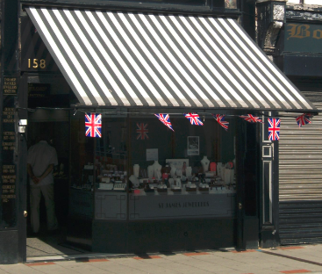
Canopies - Canopies can be a lively and traditional addition to the street scene, providing that they are an integral part of the shop front. They also provide a practical function giving protection from the elements to both product and potential customers. When installing a new canopy or blind you should not obscure other architectural features. Be aware that historic mechanisms may exist under modern signage.

Cill - Projecting horizontal bar at the bottom of a window.

Console – an ornamental bracket which supports horizontal features, often decorative.

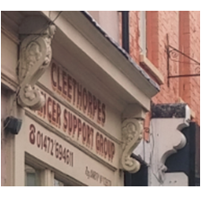
Console brackets - Consoles are a common feature of Victorian and Edwardian shop fronts. Along with pilasters they define the width of the shop front and may be highly decorated or relatively plain. They usually benefit from decorative carvings or mouldings such as scrolls or foliage to avoid a box like appearance. Console Brackets should not be overly wide and should be in proportion to the overall shop front. In most cases the console should extend the depth of the facia and be supported by a pilaster. Where original consoles and pilasters exist, every effort should be made to retain and repair them.

Cornice – a continuous horizontal, projecting feature.

Display window – window, often almost to the floor to maximise space to display goods for sale.

Entablatures - the upper part of a classical building supported by columns or a colonnade, comprising the architrave, frieze, and cornice.

Faience - is used to describe a type of detailing similar to terracotta moulding. Both terracotta and faience are formed from ground clay mixed with sand or powdered fired clay which has enough plasticity that it can be moulded into a shape. Such materials are harder and fired to a higher temperature than an ordinary clay brick and as such require clay of a higher quality. The difference between terracotta and faience is that faience is covered with one or more glazes whereas terracotta is not. The glazing imparted on faience is sometimes used to imitate stone.

Fascia – the surface above the shop window that normally contains the signage. This can be flat or angled.

Flashing – traditionally lead would be laid over the top of the cornice to direct rainwater away from the shopfront to prevent rot.

Hopper - A funnel-shaped enlargement at the top of a downspout where the gutter rainwater is received.

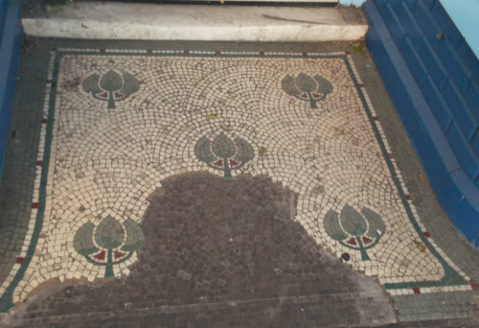
Lobby Floor - Where the door is recessed in an entrance lobby, the floor of the lobby was usually tiled, often in chequerboard pattern, or marble and frequently in mosaic. Mosaic provided an opportunity to further advertise the business in the patter of the mosaic.

Mullion – vertical glazing bar.

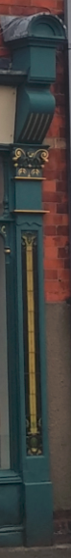
Pilasters - A pilaster is a vertical column which frames the shop front and provides visual support to the fascia and the upper floors of the building. Pilasters usually project out from the rest of the shop front and incorporate a plinth at the base and a corbel or console bracket at the apex. Within traditional shop fronts, when a single shop front extends across two or more buildings, the use/retention of pilasters provide the ideal design solution when shop front design is seeking to respect the character and identity of an individual building

Plinth – mould that projects at the foot of the pilaster.

Recessed Entrance – or lobby, where the entrance is set back to create more display windows.

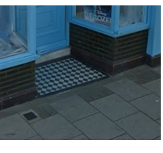
Stall riser – surface between the pavement and window. It protects the window from damage and lifts the display to that it is more visible. It is an integral part of the shop front. The height of the stall riser generally became much lower from the late 19th and early 20th centuries to the point where it became little more than a plinth or cill. Earlier stall risers were deep, but again kept in proportion with the overall design of the shop front. Stall risers may be constructed from timber (quality hardwood) with panels and moulding, brick, render, tiles, stone or faience.

Stucco - fine plaster used for coating wall surfaces or moulding into architectural decorations, often covers brickworks to make the appearance of a stone header.

Transom – horizontal glazing bar.

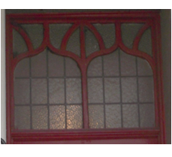
Transom light - The transom light became a feature of the late Victorian and Edwardian period, when window displays were becoming internally lit as opposed to the large hanging external gas lamps of the Georgian period. The transom light hid these lights from view when looking into the shop. Transom lights are usually leaded in simple diamond or square pattern, with plain, hammered or stained glass. The transom light in some cases provides an opportunity for additional advertising to signage as part of the glazing.

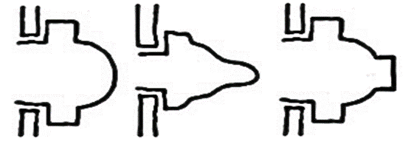
Typical glazing bar moulds -
ovolo lambs tongue ovolo & fillet

Vitrolite – pigmented structural glass, used widely in the 1920’s and 30’s for shopfront stall risers, fascias and pilasters in the Moderne or Art Deco styles.

An example of traditional shop front





